**DEPARTMENT OF INFORMATION TECHNOLOGY**

**COURSE CODE: DJS22ITL306**   **DATE:28-10-23**

**COURSE NAME:** **Programing Laboratory 1 (Advanced Java)**

**CLASS: S.Y B. Tech IT**

**Name: Anish Sharma**

**EXPERIMENT NO.2**

**CO/LO:**

**CO1**- Modify the behaviour of methods, classes, and interfaces at runtime.

**AIM / OBJECTIVE:**

To implement different generic types

**PROBLEM STATEMENTS:**

1. Write a Java program that creates 2 lists, 1 for integer and other for strings. Define a generic method to display the elements of both lists using arrays with the use of for-each loop.

import java.util.*;

class Test

{

String var;

<A>Test(A var)

{

this.var = var.toString();

}

String display() {

return var.getClass().getSimpleName();

}

void display(List<?super Integer> list) {

for (Object i : list) {

System.out.println(i);

}

}

}

public class Main

{

public static void main(String[] args)

{

Test a = new Test(100);

Test b = new Test("Amit");

Test c = new Test(true);

Test d = new Test(100.321);

Test e = new Test(100.321f);

Test f = new Test(100.321d);

System.out.println(a.display());

System.out.println(b.display());

System.out.println(c.display());

System.out.println(d.display());

System.out.println(e.display());

List<Number> l1 = Arrays.asList(1,2,1.4,50.02,50.56);

List<Integer> l2 = Arrays.asList(1,2,3,4,5);

a.display(l1);

a.display(l2);

}

}

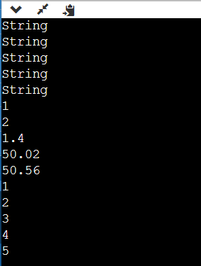

1. Write a simple generic version of method isEqualTo that compares its two arguments with the equals method and returns true if they’re equal and false otherwise. Use this generic method in a program that calls isEqualTo with a variety of built-in types, such as Object or Integer. What result do you get when you attempt to run this program?

import java.util.*;

public class Main {

public static <T> boolean isEqualTo(T first, T second) {

return first.equals(second);

}

public static void main(String[] args) {

Scanner sc=new Scanner(System.in);

System.out.println("enter two strings to check if they are equal");

System.out.println(isEqualTo(sc.next(),sc.next()));

System.out.println("enter two integers to check if they are equal");

System.out.println(isEqualTo(sc.nextInt(),sc.nextInt()));

}

}

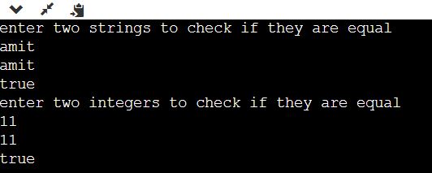

1. Write a generic method Sort based on the sort program. Write a test program that inputs, sorts and outputs an Integer array and a Float array. [Hint: Use > in the type-parameter section for method Sort, so that you can use method compareTo to compare the objects of the type that T represents.]

class Test<X,Y> {

X var1;

Y var2;

Test(X var1, Y var2) {

this.var1 = var1;

this.var2 = var2;

}

Y getValue() {

System.out.println("The type of " + var1 + " is " + var1.getClass().getSimpleName());

System.out.println("The type of " + var2 + " is " + var2.getClass().getSimpleName());

return (Y)var2.getClass().getSimpleName();

}

}

public class Main {

public static void main(String[] args) {

Test<Integer, String> a = new Test<Integer, String>(100, "Amit");

Test<Double, Boolean> b = new Test<Double, Boolean>(99.999, true);

a.getValue();

b.getValue();

}

}

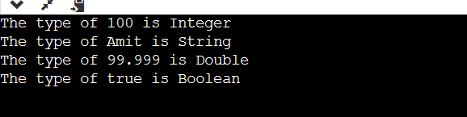

**CONCLUSION:**

We learnt to implement Genrics in java